Reception Class Learning
12/06/2020

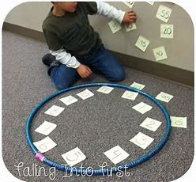
Maths Activities
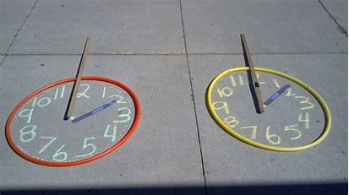
Activity 1
- Time – O'clock Can you make a clock face, putting the numbers 1-12 in order around the clock face. Can you make 2 hands to help you tell the time.
- Can you make different o’clock times?

Activity 2
- Practise your estimating and counting skills. Draw around your hand or foot on a piece of carboard and ask an adult to cut it out to make a frame.
- Place it on the grass and estimate (guess) how many flowers are in your frame and then check by counting.
- Will you have the same number if you move your frame somewhere else?
- Record your amounts/numbers

Literacy Activities
Activity 1
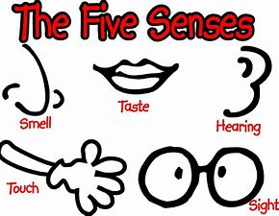
- Following on from our blog last week, write a few descriptive sentences about your senses walk.
- Write about what you could see, hear, smell, touch and maybe even taste.
- E.g. The loud cows mooing. The glistening sun on the water.
- Draw a picture of what you could see, hear, smell, touch and taste too, to go with your sentence writing
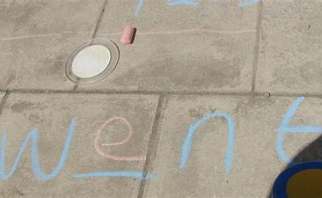
Activity 2
- Practise the letters and sounds tricky words.
- Practise writing the words using pencils, felt tips, crayons or chalks outside.

Wider Learning Opportunities
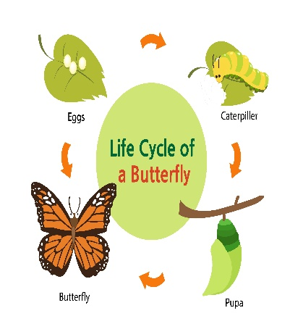
Activity 1
- Can you make a life cycle of a butterfly?
- Watch the clips below for some ideas. There many more ideas on line too!
- https://www.youtube.com/watch?v=Nr3ZfL8ryvM
- Watch this exciting song about the life cycle of a butterfly.
- Can you spot the 4 key words? Egg Caterpillar Chrysalis/Cocoon Butterfly
https://www.youtube.com/watch?v=8rvGUevGxDk

Activity 3
- Let’s have fun with shadows! Find an object in your house (this could be anything) and place it in a sunny spot where it forms a shadow.
- Place a piece of paper over the shadow and draw around the shadow.
- Leave the paper where it is (perhaps weigh it down with something heavy so it doesn’t blow away!) Come back in an hour or 2. Has the shadow moved?
- Why do you think this has happened?

Activity 4
- Create a weather diary for the week in Welsh with the title ‘Y Tywydd’
- Each day, write a sentence and draw a picture of what the weather is like.
- Below is some vocabulary to help you!
    - Mae hi’n- It is
    - bwrw glaw- raining
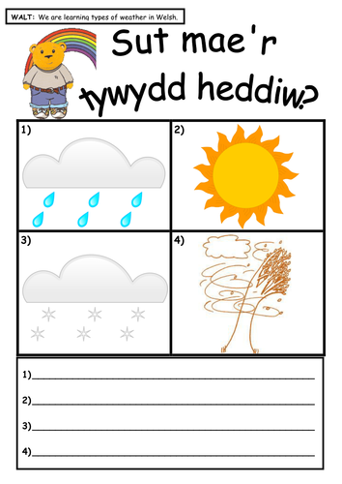
    - heulog- sunny
    - braf- fine
    - wyntog- windy
    - oer- cold
    - gymylog- cloudy

And remember to always …
- Listen to and/or sing Jolly Phonics song
- Read together and discuss a story of your choice
- Count up to 20 forwards and backwards
- Practice letter formation
- Practice number formation
- Sing days of the week song
- Keep reading

Stay safe and best wishes to all the children, Mrs Bennett & Mrs Llewelyn.

